OUTPUT RESULTS

**Violations Detected for image**

The processed images output include detected persons, motor cycles, helmets, and triple riding violations, with each identified object enclosed in a bounding box. The system assigns a confidence score to each detection, indicating the accuracy of classification. If a helmet violation is found, the image will be annotated accordingly and displaying with a message. Similarly, if a triple riding violation is detected, it will be highlighted. In cases where no violations are found, the image will reflect normal riding behavior. The model ensures reliable detection even under challenging conditions, such as rainy weather, maintaining high accuracy in various environments.

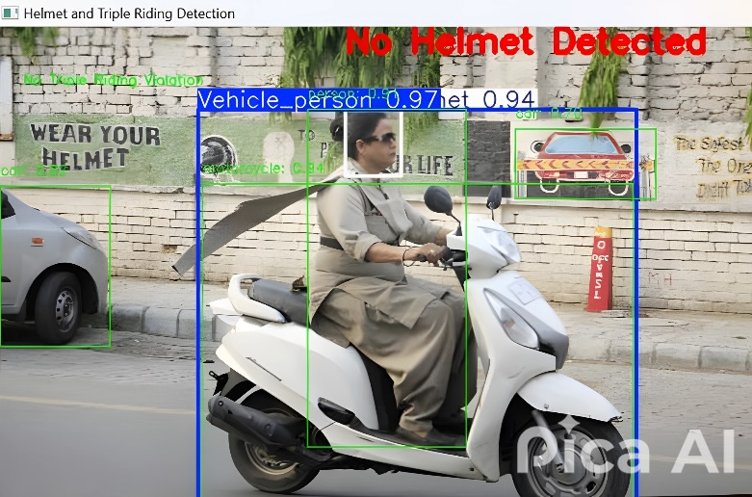

Fig. 1. Helmet Violation Detected on Single Vehicle

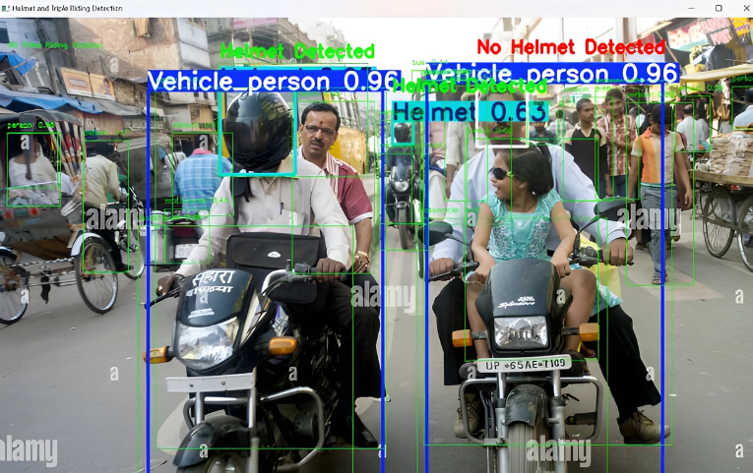

Fig. 2. Helmet Violation Detection on Multiple Vehicles

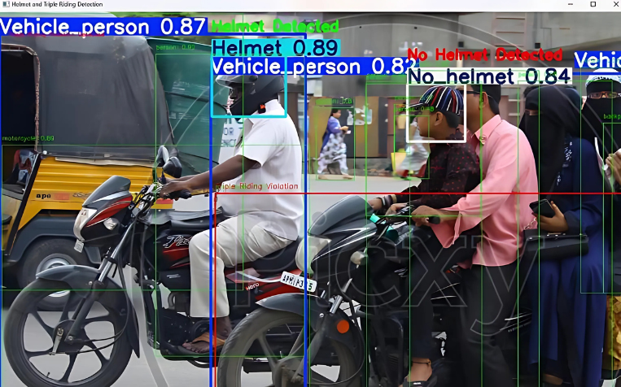

Fig. 3. Triple Riding Violation Detected

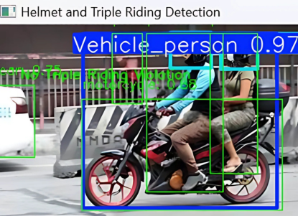

Fig. 4. No Triple Riding Violation Detected

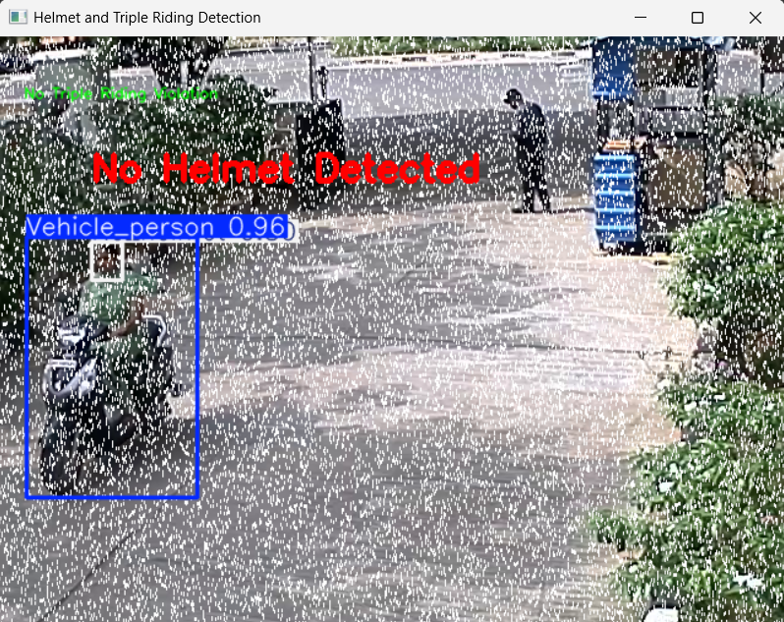

Fig. 5. Helmet Violation Detected in Rainy weather Conditions

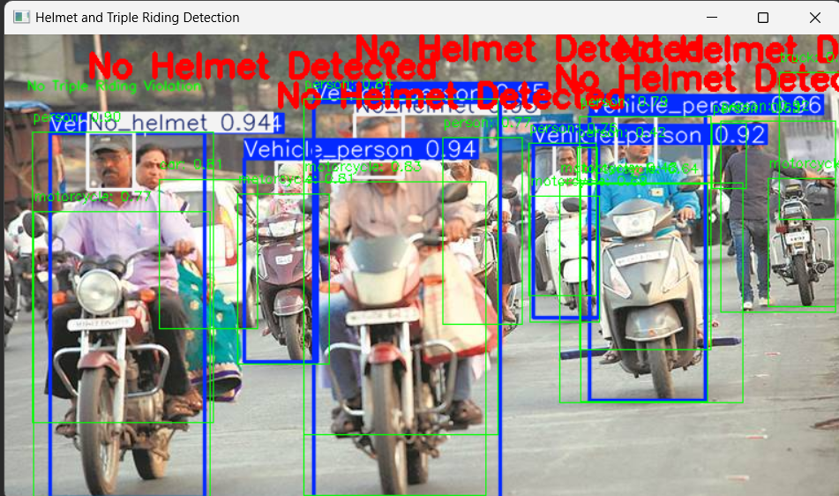

Fig. 6. Helmet Violations Detected on multiple vehicles

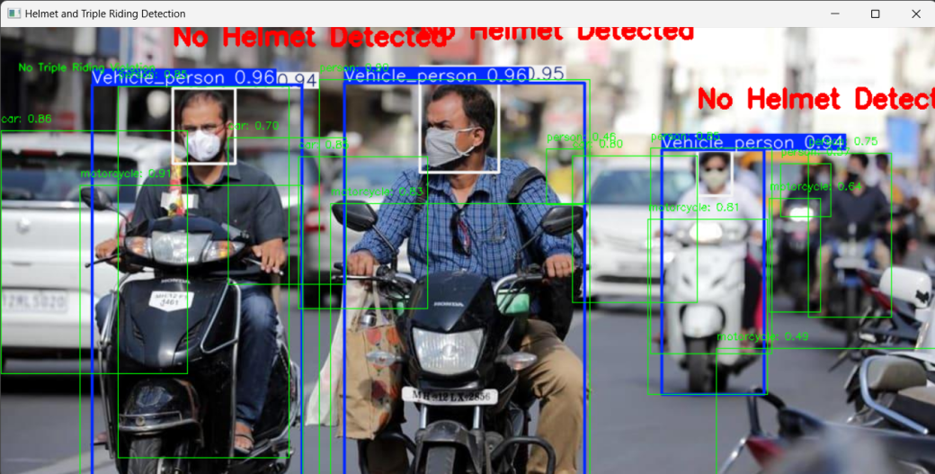

Fig. 7. No Helmet and Triple Riding Violations Detected

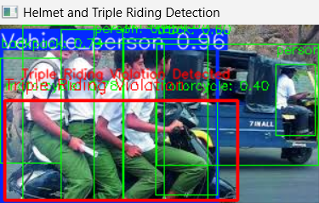

Fig. 8. Triple riding Violations Detected

**Violations Detected for Videos**

Helmet and Triple Riding Violations on the videos are attached below(screenshots).

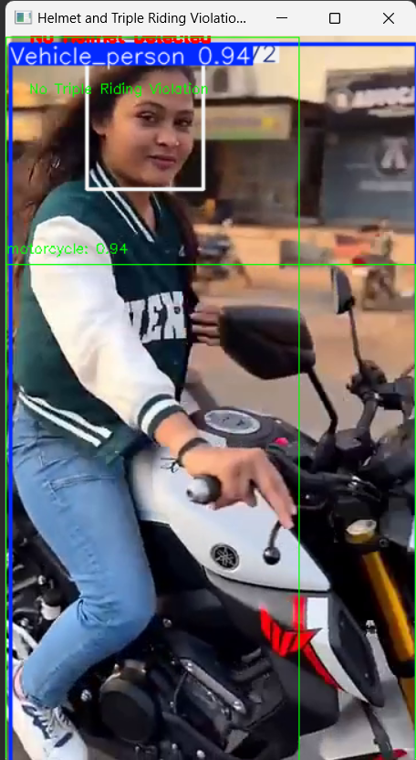 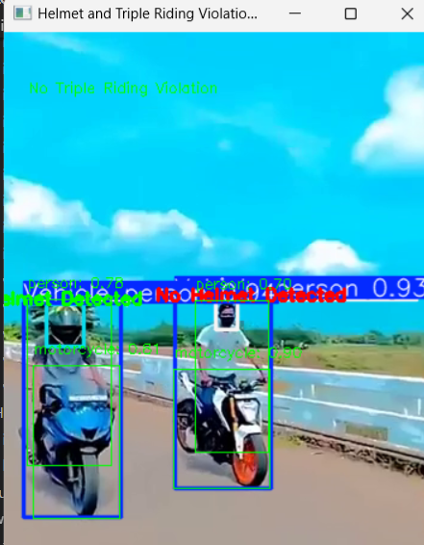

For videos, the system performs real-time detection of persons, helmets, and triple riding violations, similar to image processing. Each frame of the video is analyzed individually, with bounding boxes marking detected objects and confidence scores indicating accuracy. The system continuously tracks violations, such as helmet non-compliance and triple riding, ensuring consistent detection across multiple frames. Annotated screenshots from the video highlight detected violations, providing a clear visual representation of the results.

